**Biology STAAR Review Stations**

**Day 7**

**Category # 3 Biological Evolution and Classification (7.E, 7.F, 7.G)**

7.E analyze and evaluate the relationship of natural selection to adaptation and to the development of diversity in and among species

7.F analyze and evaluate the effects of other evolutionary mechanisms, including genetic drift, gene flow, mutation, and recombination

7.G analyze and evaluate scientific explanations concerning the complexity of the cell

**7.E, 7.F, 7.G Pre-Test Score__________ Focus TEKS__________**

|  |  |  |  |
| --- | --- | --- | --- |
|  | **7.E** | **7.F** | **7.G** |
| **Interactive Quizzes** | **Natural Selection Tutorial and Quiz**  <http://bcs.whfreeman.com/thelifewire/content/chp23/2302001.html> | **The Evolution of Organisms**  <http://nortonbooks.com/college/biology/animations/ch05a09.htm>  Go through narration and take the quiz. Show results to the teacher. | |
| **Graphic Organizers** | **Natural Selection Graphic Organizer**  See handout | **Mechanisms of Evolution**  <http://evolution.berkeley.edu/evosite/evo101/IIIMechanisms.shtml>  Draw pictures of the following mechanisms of evolution:  Descent  Mechanisms of Change  Genetic Variation  Genetic Drift  Natural Selection  Coevolution | **Multicellular Life Graphic Organizer**  **See handout** |
| **Virtual Labs** | **How Can Natural Selection be Modeled?**  **http://www.glencoe.com/sites/common_assets/science/virtual_labs/LS06/LS06.html** | **Effects of Other Evolutionary Mechanisms**  [**http://tinyurl.com/lqwrwvh**](http://tinyurl.com/lqwrwvh) | **Natural Selection: Fact or Fiction**  [**http://www.discovery.com/tv-shows/curiosity/topics/natural-selection-quiz.htm**](http://www.discovery.com/tv-shows/curiosity/topics/natural-selection-quiz.htm) |
| **Vocabulary** | **Animal Adaptation Flashcards**  http://quizlet.com/6108125/animal-adaptation-unit-flash-cards/ | **Evolutionary Mechanism Flashcards**  <http://quizlet.com/43997765/bisc-120-evolutionary-mechanisms-flash-cards/> | **Cell Complexities Flashcards**  <http://quizlet.com/52126577/evolutionary-mechanisms-and-cell-complexity-vocabulary-flash-cards/> |
| **Video Clips** | **Animal Adaptations**  <http://www.youtube.com/watch?v=fRX2JtKFUzk> | **Mutations: The Potential Power of a Small Change**  Watch the video clip at:  <https://www.youtube.com/watch?v=GieZ3pk9YVo>  Complete the video recap handout while you watch.  <http://amoebasisters.weebly.com/uploads/2/1/9/0/21902384/video_recap_of_mutations_by_amoeba_sisters.pdf> | **The Endosymbiosis Theory: Evolution of Cells Video and Quiz**  <http://education-portal.com/academy/lesson/the-endosymbiosis-theory-evolution-of-cells.html#lesson>  Watch the video and complete the quiz. Show quiz results to the teacher. |

**7.E, 7.F, 7.G Critical Thinking Questions**

1. What are the different reasons species are successful today?

2. What are the effects of other evolutionary mechanisms on today’s species?

3. How does natural selection explain how organisms have changed over time?

4. Scientists believe that the eukaryotic cell is made of several other cell types. Discuss evidence of this theory.

5. Discuss explanations over the complexity of the cell

**7.E Natural Selection Graphic Organizer**

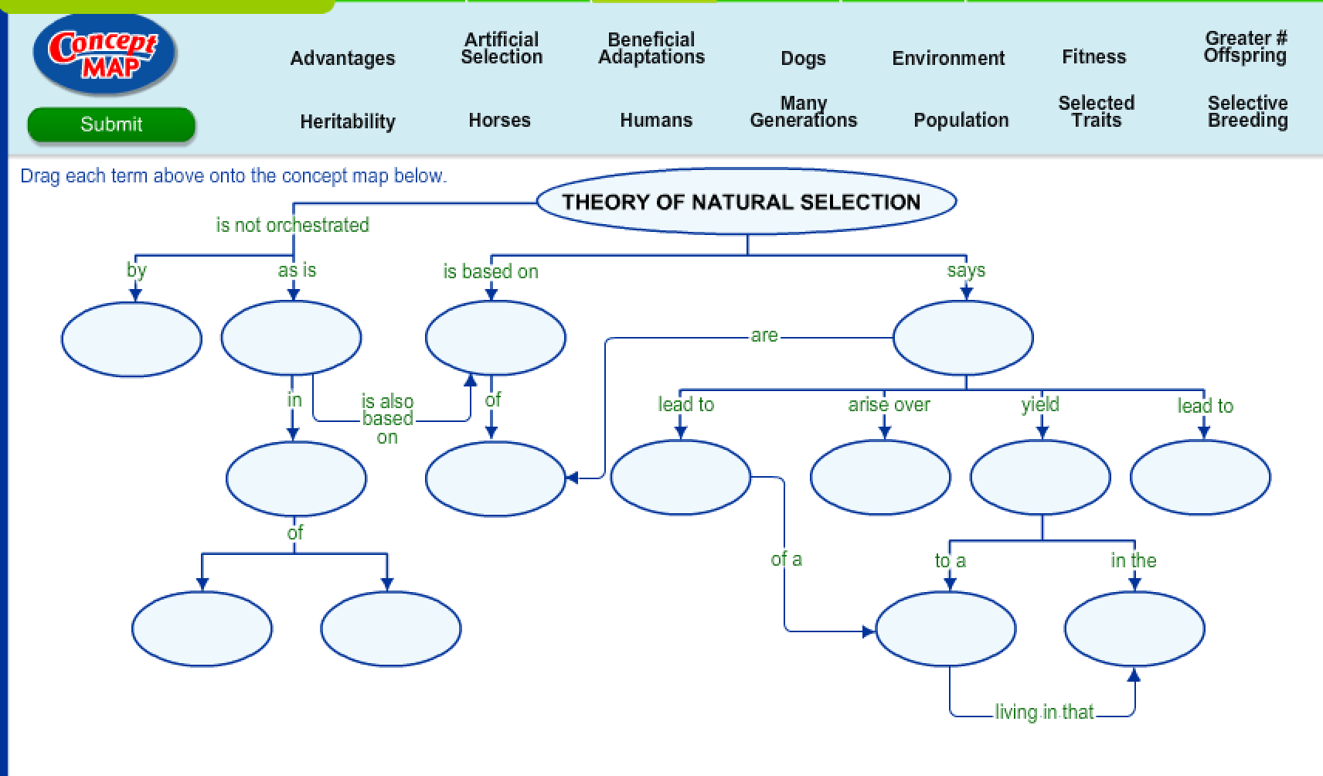

**7.F Mechanisms of Evolution Graphic Organizer**

Illustrate the following mechanisms of evolution:

|  |  |
| --- | --- |
| **Descent** |  |
| **Mechanisms of Change** |  |
| **Genetic Variation** |  |
| **Genetic Drift** |  |
| **Natural Selection** |  |
| **Coevolution** |  |

**7.G Multicellular Life Graphic Organizer**

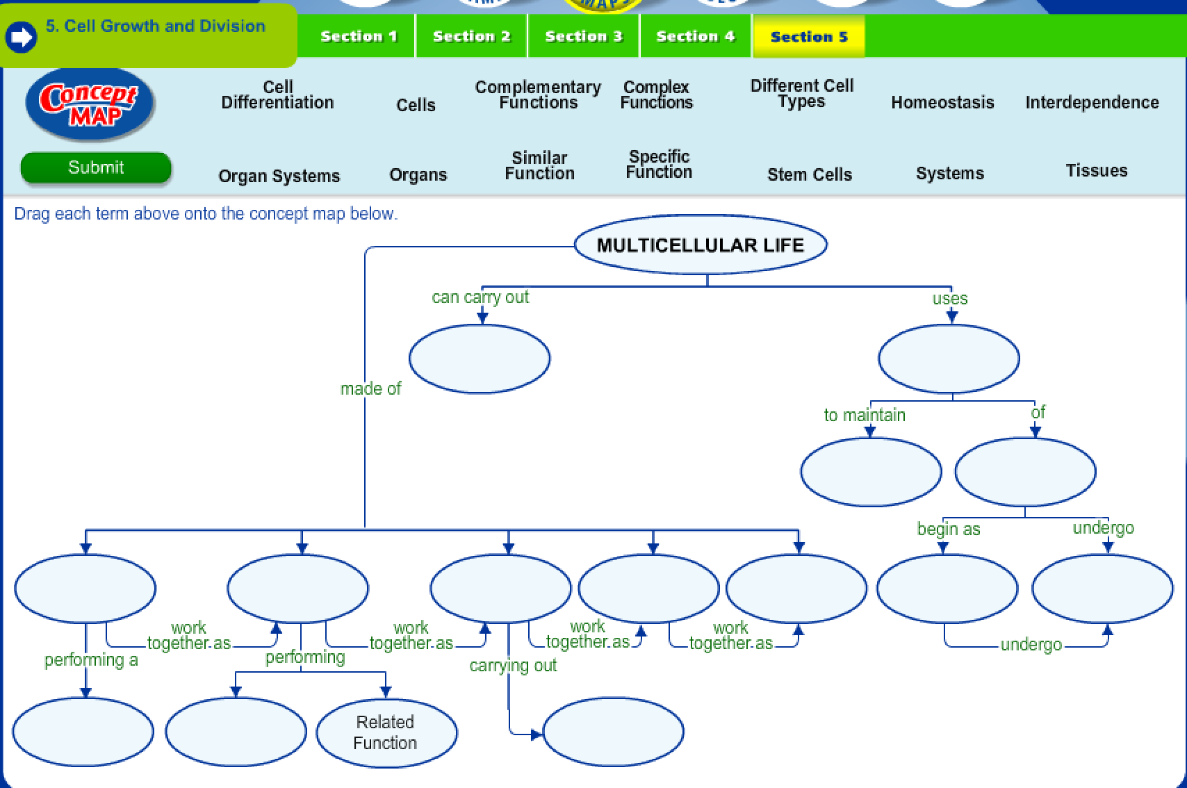

**Day 7 Review Questions**

7.E

_____ 1. A male peacock evolves to have an elaborate display to get the attention of females. Which evolutionary force is working here?

**a.** co-evolution

**b.** sexual selection

**c.** artificial selection

**d.** adaptive radiation

7.E

_____2. Identify which of the following is a vestigial structure?

a. the human tailbone

b. the bill of a finch

c. flower color

d. fossil cast

7.E

_____3. Natural selection and its evolutionary consequences provide a scientific explanation for each of the following except:

1. a stable environment
2. the fossil record
3. protein and DNA similarities between different organisms
4. similar structures among different organisms

7.E

_____4. Penicillin has long been used to fight bacterial infections. According to natural selection, why are so many bacterial populations resistant to the original form of penicillin?

a. different bacterial species evolved due to geographic isolation

b. the use of penicillin induced mutations that promote resistance to penicillin

c. different bacterial species evolved due to behavioral isolation

d. the presence of penicillin was an environmental pressure that selected for bacteria that were resistant to it

7.F

_____5. A small spider mite species has populations on several islands in the South Pacific. They live inside coconuts and exclusively eat smaller insects on the outer husk of the coconuts. During heavy storms, coconuts with these spider mites can be carried from one island to another where the mites successfully breed with members of the same species on the new island. This is an example of:

1. gene flow
2. mutation
3. bottleneck
4. genetic mutation

7.F

_____6. How do we measure variation in a population?

a. The number of alleles present

b. The number of phenotypes

c. The number of individuals

d. all of the above

7.F

_____7. Which of the following are evolutionary factors?

a. Gene flow

b. Genetic drift

c. Natural selection

d. Mutation

e. All of the above

7.F

_____8. A squirrel runs into Route 195 and gets hit by a car. The change in the local population is represented by...

**a.** gene flow

**b.** genetic drift

**c.** bottleneck effects

d. adaptive radiation

7.G

_____9. The theory of endosymbiosis best explains:

a. How eukaryotic cells evolved from prokaryotic cells

b. How prokaryotic cells evolved from protobionts

c. How all eukaryotic cells contain chloroplasts

d. Why eukayotic cells have a nucleus

7.G

_____10. Which of the following best describes early cellular life?

1. the first cells were photosynthetic an did not require oxygen
2. the first cells were very similar to present day eukayrotic cells
3. the first cells were anaerobic and broke apart small molecules for energy
4. the first cells took in oxygen from fresh water

7.G

 _____11. Any variation that can help an organism survive in its environment is called a(n):  
   a. adaptation  
   b. characteristic  
   c. competition  
   d. vestigial structure

7.G

_____12. Genetic variability between individuals of a population or species is caused by

1. random mutations
2. mitosis
3. sexual propagation
4. a and c

**Day 7 Review Questions (7.E, 7.F, 7.G)**

**Answer Sheet**

**_____1.**

**_____2.**

**_____3.**

**_____4.**

**7.E Score__________/4**

**_____5.**

**_____6.**

**_____7.**

**_____8.**

**7.F Score__________/4**

**_____9.**

**_____10.**

**_____11.**

**_____12.**

**7.G Score__________/4**

**Day 7 Review Questions (7.E, 7.F, 7.G)**

**Key**

**__B__1.**

**__A__2.**

**__A__3.**

**__D__4.**

**__A__5.**

**__A__6.**

**__E__7.**

**__B__8.**

**__A__9.**

**__C__10.**

**__A__11.**

**__D__12.**